

West Australian Test Papers

PHYSICS

Year 12

2006

SOLUTION BOOKLET

&

MARKING GUIDE

Markers should note that the solutions presented here are skeletal answers and should be used as a guide only.

Alternate answers used by students may be perfectly acceptable and discretion should be used.

Section A

1(a)
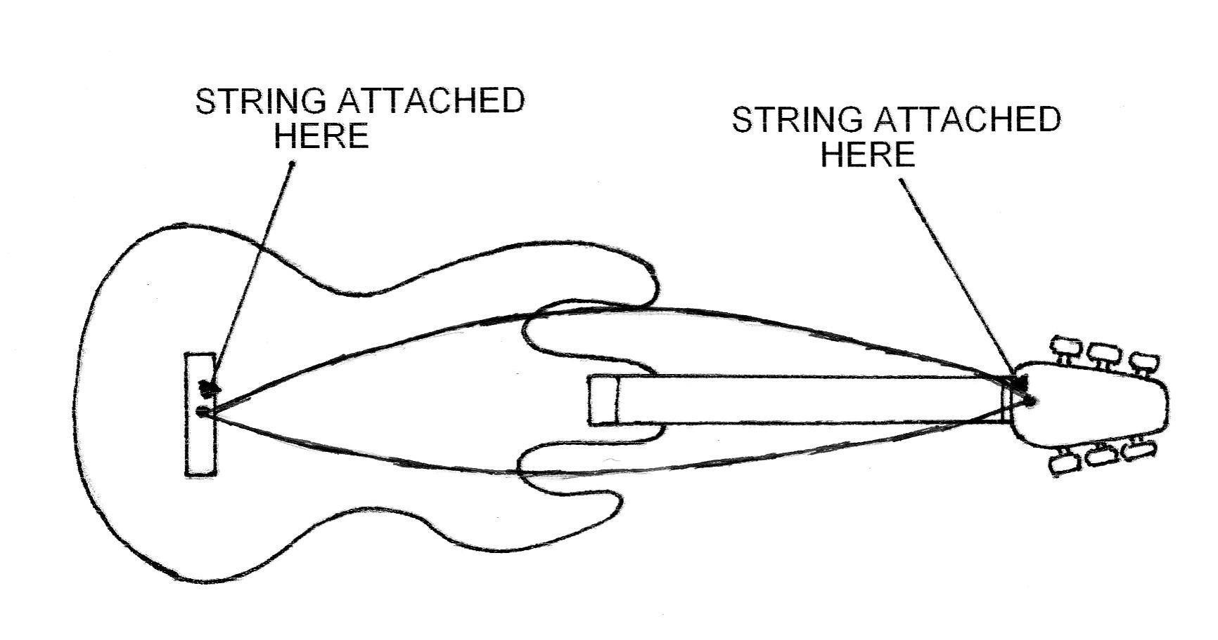

- length = wavelength / 2 therefore wavelength = 1.20 m
v = f x λ
v = 440 x 1.20 = 528 m s⁻¹

2 (i) Distance between nodes is 2.75 m which is half the wavelength.
Therefore the wavelength is 2 x 2.75 = 5.5 m

(ii) v = f x l
346 = f x 5.5
f = 62.9 Hz

3 In the horizontal
v_{h} = s / t
s = v_{h} / t
t = 4.2 / v_{h} ……………………………(1)

In the vertical
2 = 0 + 0.5 (9.8 x t²) …………………….(2)

Substitute for t = 4.2 / v_{h} in equation (2)

2 = 0 + 0.5 [9.8 x (4.2 / v_{h})²]

Horizontal velocity v_{h} = 6.6 m s⁻¹

4 A communications satellite needs to remain in the same place above the Earth to enable constant communication so needs to be in a geosyncronous orbit.
Polar orbits sample a large area of the earth in a given time so are suitable for providing information about the global weather.

- Use KE = 0.5 m v²

1.7 x 10⁻¹⁸ = 0.5 x 9.11 x 10⁻³¹ x v²
v² = 3.732 x 10¹²
v = 1.93 x 10⁶ m s⁻¹

r = m v / B q

r = (9.11 x 10⁻³¹ x 1.93 x 10⁶) / (6 x 10⁻⁵ x 1.6 x 10⁻¹⁹)
= 1.83 x 10⁻¹ m

6 Speed across river = s / t
1.5 = 35 / t
t = 23.33 s
distance downstream = 3.5 x 23.33 = 81.67 m

(displacement) ² = 81.67² + 35²

displacement = 88.9 m

7 Sun - The spectrum will be continuous from red to blue with black lines superimposed on it
Light globe - Continuous spectrum with red to blue but without the black lines.

8(i)
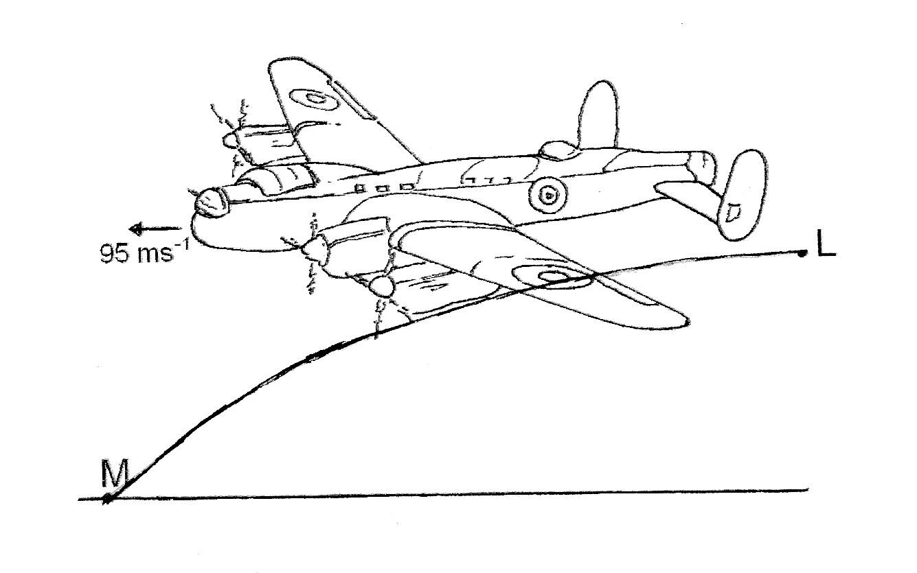

- There is no horizontal acceleration so the horizontal velocity remains constant if air resistance is ignored.

- v² = u² + 2a s

32² = 0 + 2 x 9.8 x s

S = 52.2 m

- Truss A is more rigid. The oblique struts of truss A have vertical and horizontal force components which prevent the truss from moving laterally. Truss B struts have no horizontal force components so there is a possibility that it will move laterally.

- (a) If the frequency is increased then the induced voltage and current is increased and its flow will dissipate heat in the metal pan.
  - The pan needs to be made of a conducting material so the current can be induced in the conductor and hence produce heat.

11 [Estimate mass of student = 70 kg and length of wire is 0.8 m]
Young’s Modulus = (F x l) / (A x Δl)

1.93 x 10¹¹ = (700 x 0.8) / (2 x 10⁻⁵ x Δl)
Δl = (700 x 0.8) / ( 2 x 10⁻⁵ x 1.93 x 10¹¹)
Δl = 1.45 x 10 ⁻⁴ m

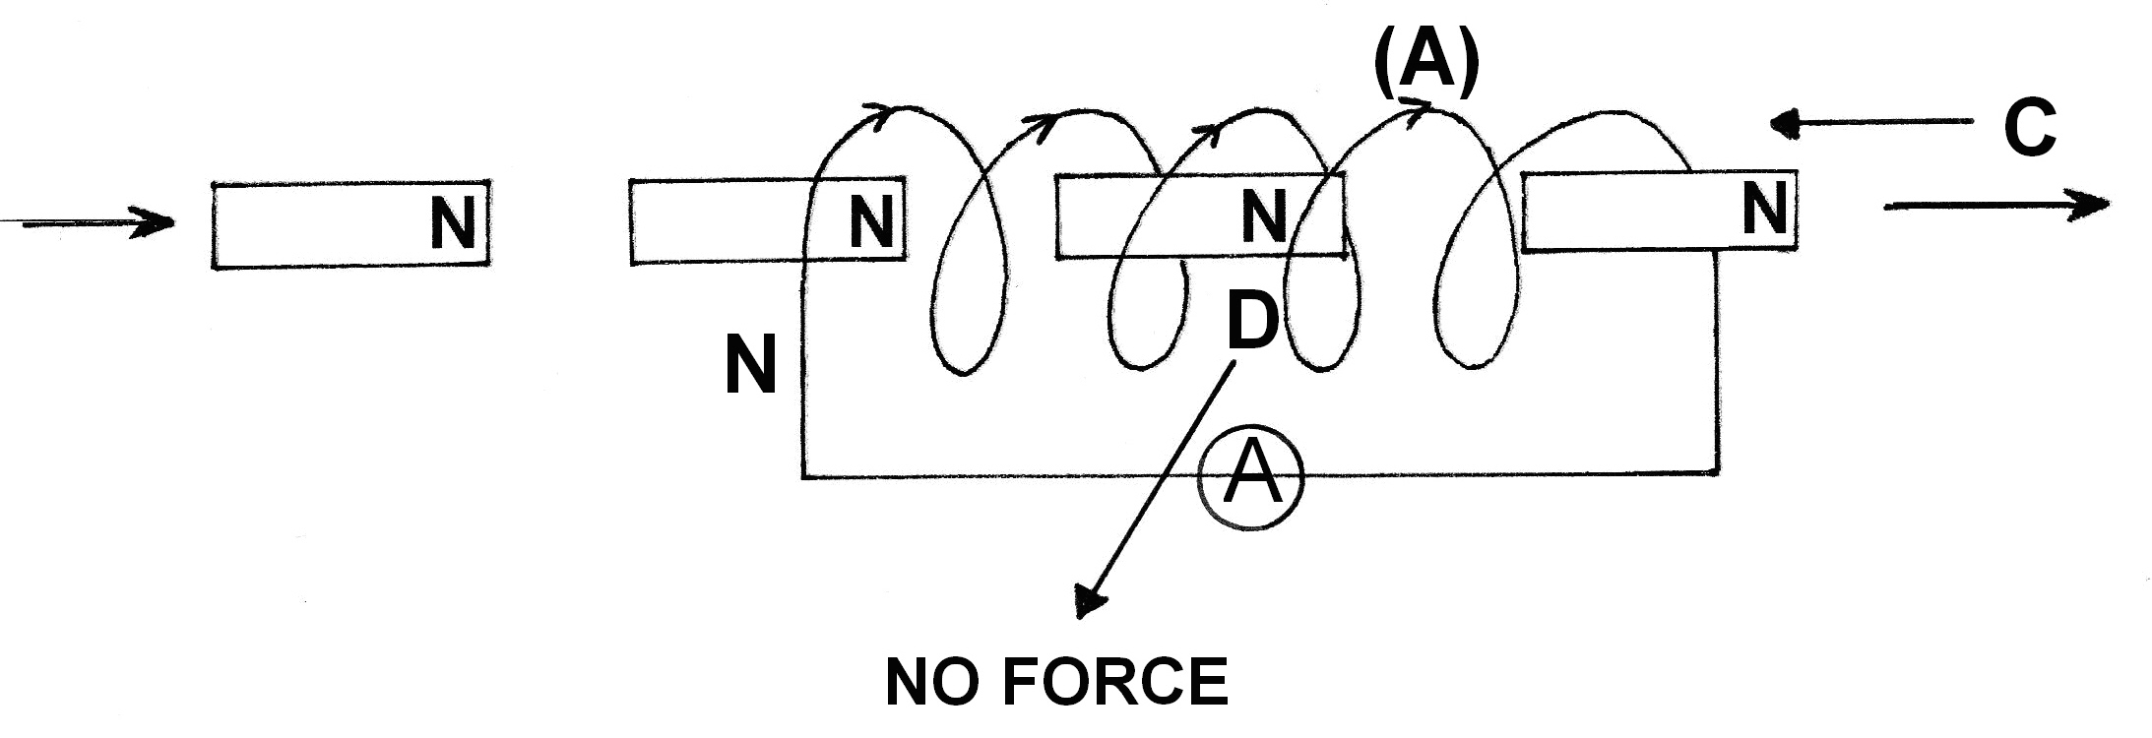

- 60 = 10 log I₁ / 10⁻¹²

I₁ = 10⁶ x 10⁻¹² = 10⁻⁶ W m⁻²

I₂ 10⁷ x 10⁻¹² = 10⁻⁵ W m⁻²

dB = 10 log₁₀ 1.1 x 10⁻⁵ / 10⁻¹²
dB = 70.4 dB

- Vase A is more stable. Both vases have the same width of base but vase B has a higher centre of mass. This would cause vase B to topple when it is displaced less than when vase A is displaced because its centre of mass would be acting outside the base.

- Street lamps that emit coloured light are likely to have transitions that produce energy corresponding to frequencies in the yellow/orange part of the visible spectrum. Electrons are promoted to energy levels within the atom and when they return to a lower energy level photons of a discrete frequency is emitted.

Section B
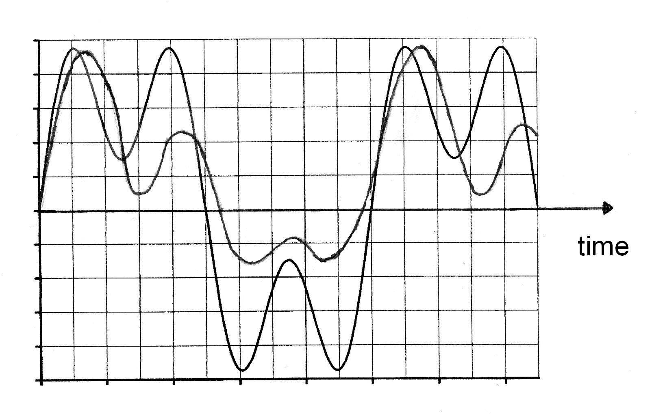
1(a)

- length of tube = wavelength / 4
wavelength is 4 x 0.654 = 2.61 m
position X indicates the 3thd harmonic because the tube is closed.
length = 3 λ / 4
so λ = (4 x 0.654) / 3 = 0.87 m
and frequency is 397 Hz
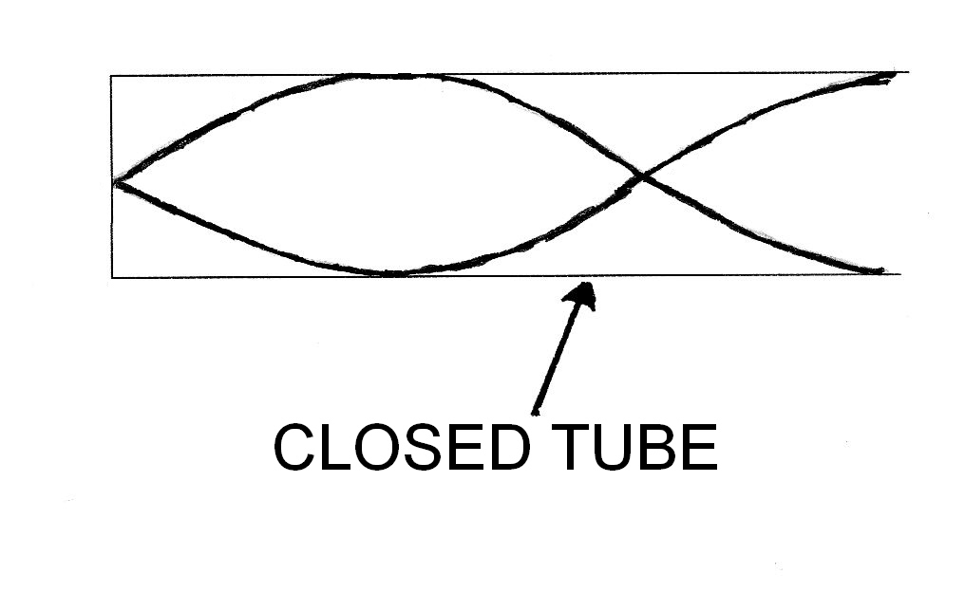
(c)

(d) 346 = f x 0.654
f = 529 Hz

- The two waves interfere
The two waves are identical
The two waves must be travelling in the same medium.

2(a) When a projectile is released higher than its landing place the optimum angle of release for maximum range is less than 45º.

- v_{h} = V_{o} cos 33º

(c) v_{v} = V_{o} sin 33º

(d) 65.25 = V_{o} cos 33 t + 0 ………………………………..(1)

2.1 = - V_{o} sin 33 t + 4.9 t² ………………………………(2)

2.1 = (-V_{o} sin 33 x 65.25) + 4.9 t²
V_{o} cos 33

2.1 = (- 0.65 x 65.25) + 4.9 t²

t = 3.01 s

Substitute this value into equation (1)

65.25 = V_{o} x (0.838 x 3.01)

V_{o} = 25.8 m s⁻¹

The initial velocity of the javelin is 25.8 m s⁻¹ at 33º to the horizontal.

3 (a) The perpendicular distance (d) from base of the mast to front stay is given by:
tan θ = 2.74 / 4.88
θ = 29.309º
sin 29.309 = d / 4.88
d = 2.388 m

The perpendicular distance (d₁) from base of mast to back stay is given by:
φ = 45º ( isosceles triangle)
sin 45 = d₁ / 4.88
d₁ = 3.450 m

Take moments about the base of the mast P
Σ CM = Σ ACM
T x 3.450 = 1 000 x 2.388
T = 692 N

Tension in the back stay = 692 N

(b) Horizontal component (H) of front stay:
H = 1 000 x sin 29.309 = 489.5 N
Vertical component (V) of front stay:
V = 1 000 x cos 29.309 = 872.0 N

Horizontal component (H) of back stay:
H = 692 x sin 45 = 489.3 N
Vertical component (V) of back stay:
V = 692 x cos 45 = 489.3 N

Sum of vertical forces = 1 715 + 872.0 + 489.3 = 3 077 N

Sum of horizontal forces = 489.3 - 489.3 = 0 N

(Resultant of the two forces)² = ((3.08 x 10 ³) ² + 0²)
Resultant force that the mast exerts on the deck = 3.08 x 10 ³ N vertically. Therefore the reaction force of the deck on the mast is 3.08 x 10 ³ N

(c) Because the resultant of the horizontal components of the front and back stays are equal, the mast will have no tendency to move towards the back or front along the deck.

4 (a) Ultra violet light
Fluorescence

(b) Maximum energy for a transition is (h x f)
= 1.6 x 10⁻¹⁹ x 3.29

f = (3.29 x 1.6 x 10⁻¹⁹) / (6.64 x 10⁻³⁴) = 7.9 x 10¹⁴ Hz

minimum frequency is (7.9 x 10¹⁴ x 1.52) / 3.29 = 3.66 x 10¹⁴ Hz

No. This radiation is in the infra red and is therefore not high enough energy.

(c) (i) There would be nothing to observe.

(ii) E₁ to E₃ Electrons would be detected and the electrons would rebound with energy of 0.04 eV

E₁ to E₂ Electrons and the electron would rebound with energy of 1.13 eV

(d) (i) 7.9 x 10¹⁴ Hz
(ii) Infra red radiation

5 (a) A transformer can only operate if there is a continual flux linkage in the secondary coil.
Therefore to step down the voltage from 25 kV to 600 V the current must be a.c. Also to
minimise energy losses power is transmitted at high voltage (25 kV) and low currents rather than lower values (600 V).

(b)
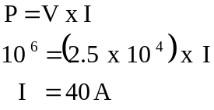

(c)
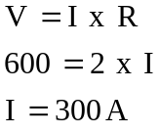

(d) Resistance in the lines = 20 x (2.1 + 2.1) = 84 Ω
(2 lines each with 2.1 Ω)

V_{drop} = I x R = 84 x 28 = 2 352 V

Voltage which is available to operate train = 25 000 - 2 352 = 22 648 V
= 22.6 kV

- (a) Take moments about the base of the crane arm.

Sum of ACM = Sum of CM

[(700 x 9.8) x (8 x cos 35)] + [(300 x 9.8) x (4 cos 35)] = T x d (where d = 6 sin 20º)

4.5 x 10⁴) + (9.6 x 10³) = T x 2.05
T = [(4.5 x 10⁴) + (9.6 x 10³)] / 2.05 = 2.66 x 10⁴ N

(b) At the base of the crane arm the vertical force is:
(700 x 9.8) + (300 x 9.8) + (T x sin 15) = 1.66 x 10⁴ N

At the base of the crane arm the horizontal force is:
(T x cos 15) = 2.57 x 10⁴ N

Reaction force at base of crane arm is 3.05 x 10⁴ N

(c) Tan θ = (1.66 x 10⁴) / (2.47 x 10⁴) = 0.6459 = 32.8º to the horizontal.
Or 57° to the vertical

7 (a) (i) Speed = distance / time
distance = (3 x 10⁸) x ( 68 x 10⁻³) = 2.04 x 10⁷ m

(ii) g = G m / r² = [(6.67 x 10⁻¹¹) x (5.98 x 10²⁴)] / [(6.37 x 10⁶) + (2.04 x 10⁷)]²

= 3.98 x 10¹⁴ / 7.16 x 10¹⁴ = 0.55 m s⁻²

(b) (i) m v² / r = G m M / r²

v² = G M / r = (6.67 x 10 ⁻ ¹¹) x (5.98 x 10²⁴) / (2.67 x 10⁷)

v = 3.86 x 10³ m s ⁻¹

(ii) speed = distance / time
(3.86 x 10³) = 2π x (2.67 x 10⁷) / t

time = 4.3 x 10⁴ s = 0.503 days
So number of times the satellite orbits per day is 1.98 times.

8 (a) emf = - Δ v / Δ t [t for a quarter turn is (3.75 x 10⁻³) s]
= 300 x (0.15 x 0.10) x 0.2 / (3.75 x 10⁻³)
= 240 V

(b) AC. The flux linkage is changing in magnitude and in direction for each 360º rotation.

(c) increase the speed
Increase the magnetic field
Increase the number of turns on the coil
(d)
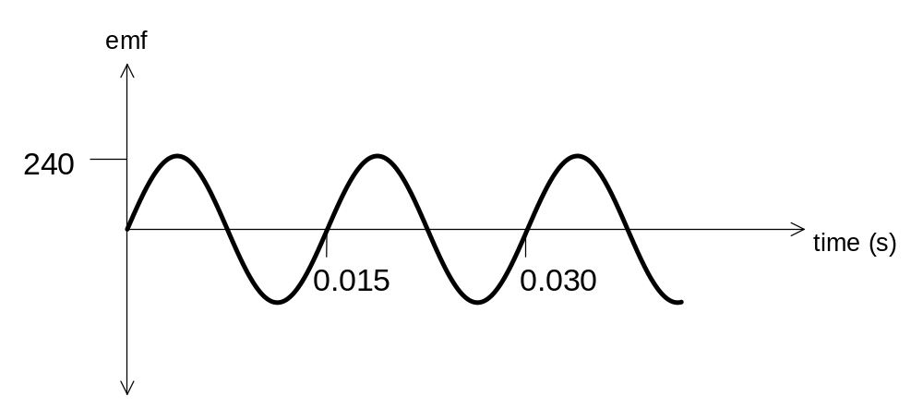
NOTE: The above graph shows average emf only. The peak emf would be 310 V
(e) No. As the coil spins the emf will fluctuate between a maximum and a minimum as the coil links with the magnetic flux.

Section C

- F = G m₁ m₂ / d²
If m₂ is large then it can exert a large force of attraction on the other objects due to gravitational pull. Once it “absorbs” the mass of these objects it will increase its mass and attract even more objects over a greater distance.

- 4 Π² r³ / T² = G M_{sun}
r³ = G M_{sun} T² / 4 Π²

r³ = (6.67 x 10 ⁻ ¹¹) x (1.99 x 10³⁰) x (288 x 365 x 24 x 3600)² / 4 Π ²
r = (2.77 x 10 ³⁸)^{1/3}
r = 6.52 x 10¹² m
3 Density of earth (E) = density of Quaoar (Q)
Radius of earth is 6.37 x 10⁶ m
Radius of Quaoar = 6 x 10⁵ m
Density = mass / volume
Mass of Q = density of Q x volume of Q
Mass of E density of E x volume of E
Mass of Q = (4/3 Π r_{Q}³)
Mass of E (4/3 Π r_{E}³)

Mass of Q = 600 x 10³
Mass of E 6.37 x 10⁶
Ratio of Q to E is 8.36 x 10⁻⁴

4 a Jupiter has a very large mass and hence a very large gravitational attraction.

b (i) The graph could be used by finding the area under the curve starting at
6.4 x 10³ on the y axis and calculating the distance that would equate
to 4.0 x 10¹¹ J of energy on the x axis. (see diagram)
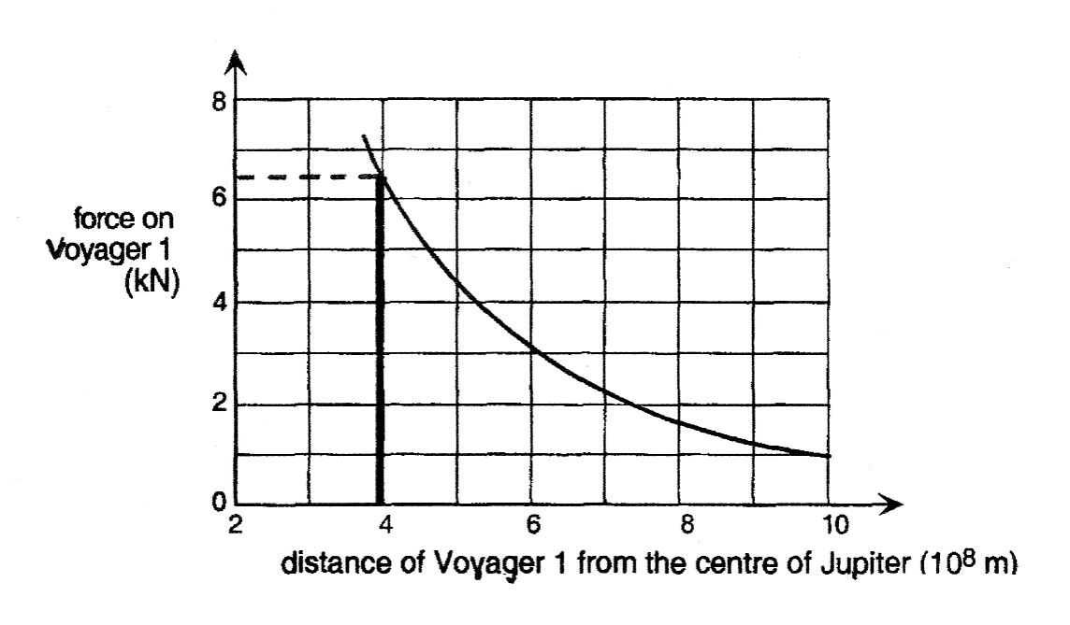

(ii) The standard formula of work = force x distance requires a constant (or average) force but the graph indicates that the force is not constant.

- Distance between Pluto and Charon = 21 000 km
Mass Pluto : Mass Charon :: 6 :1 = 7
6/7 :: 1/7
Therefore the distance between the two objects is 1/7 (21 000) : 6/7 (21 000)
Therefore the centre of mass is 3 000 km from the centre of Pluto

- Various answers acceptable depending on how the student has interpreted the passage.

Question 2
- The induced emf relies upon Faraday’s Law. The emf is directly proportional to the rate of flux linkage which depends on the velocity.
OR
E = B.v.ℓ
- If the field is uniform it will guarantee that the induced emf is a reliable reproduction of the sound waveform. This is because the velocity with which the air molecules move back and forth is the same as the ribbon

- The mass of the magnet is large because it needs to have a relatively large inertia. The weak springs will require little force to make them oscillate so the displacement of the magnet will be relatively large.

- The number of turns in the primary coil determines the amount of flux produced by the current. The number of turns in the secondary coil increases t he emf in direct proportion to the primary coil.

5 emf = N (Φ₁ – Φ₂) / t
= 1 500 [(3.4 – 0.4) x 10⁻²] / 0.125
= 360 V

6 clockwise.

7 Mutual inductance. A transformer is used to step up or step down emf. It relies upon two coils being close to one another and the primary coil inducing an emf in the secondary coil. The emf induced in the secondary coil is directly proportional to the number of turns on the secondary coil.

8 An internal battery would require surgery to change it when it became flat.

9 The primary coil has a small resistance with a large current flowing through it.
Therefore the coil would get hot.

